How to make .env variables dynamic

* task send mail by set .env variables dynamic
flow process:- how .env file work ,
config/ mail.php file -> data move in .env file
every time when we run prj firstly provider/AppServiceProvider.php file ->boot ()function runs
so do code in boot() function and main thing Config::set(.....); use atlast to set changes in config file

(when we set changes in config file then automatic mail.php changed )

php artisan tinker : tikenr practice

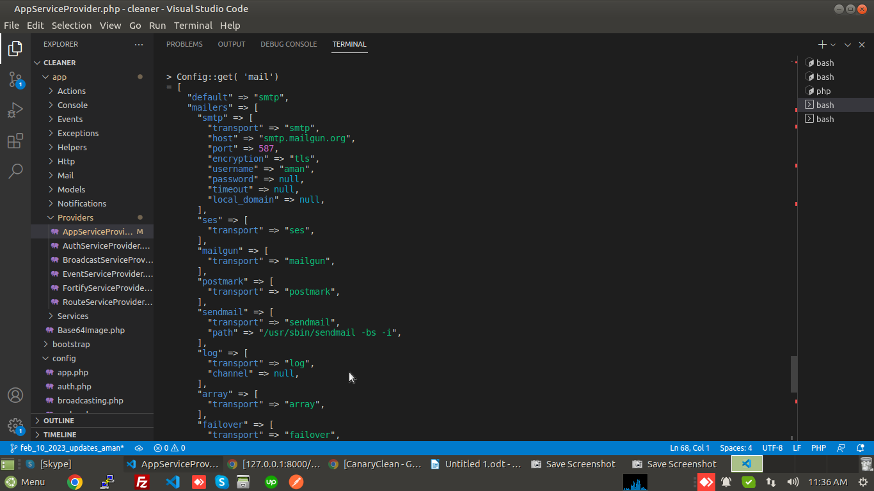

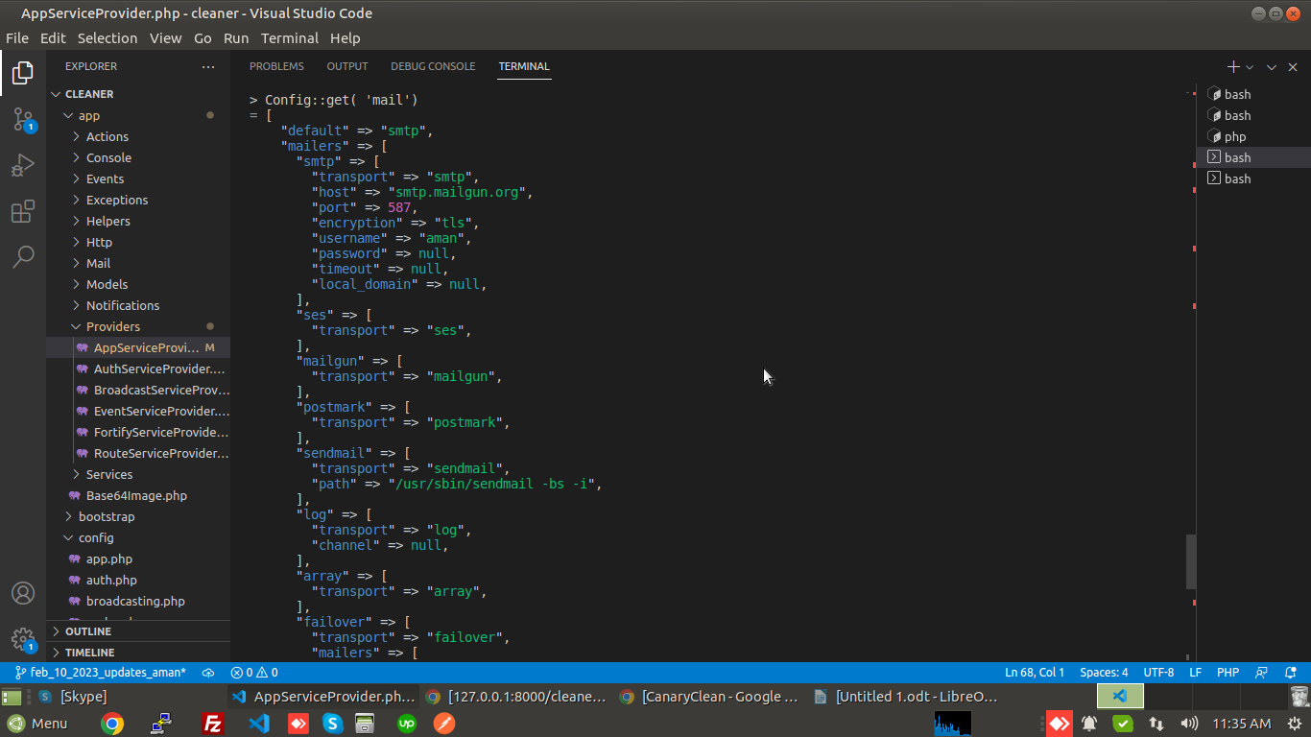
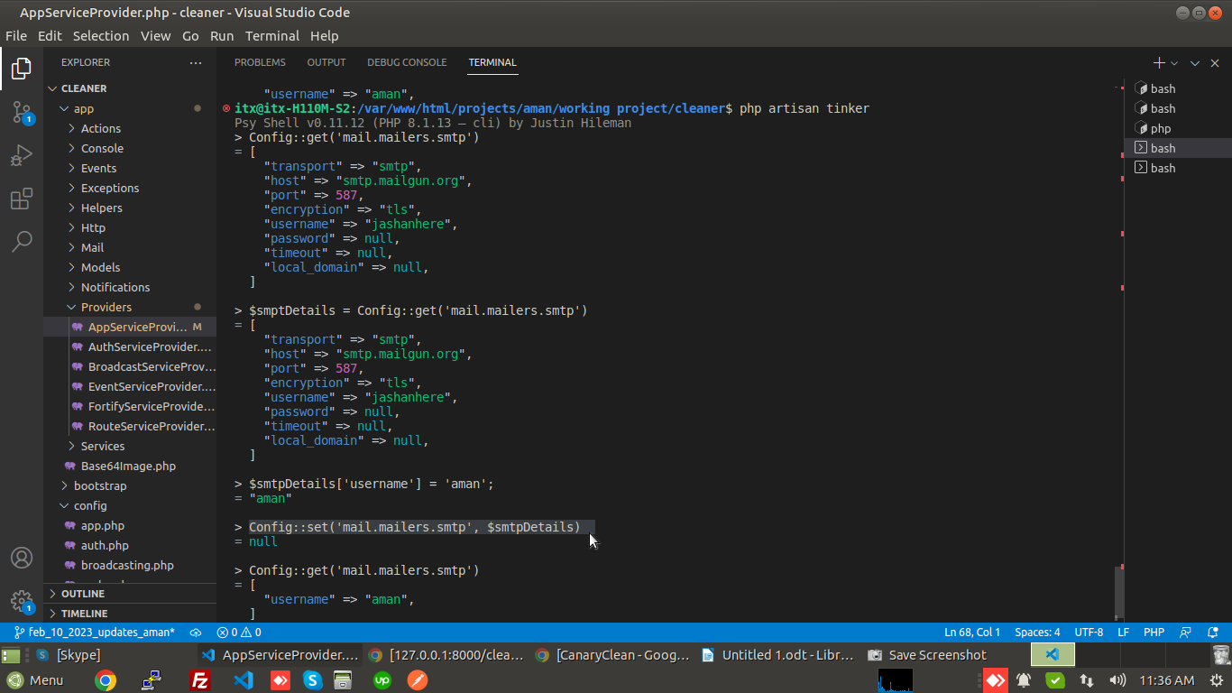

<?php

namespace App\Providers;

use App\Models\Setting;
use Illuminate\Support\ServiceProvider;
use \Stripe\StripeClient;

use Illuminate\Support\Facades\Config;

// use Config;

class AppServiceProvider extends ServiceProvider
{
/**
* Register any application services.
*
* @return void
*/
public function register()
{
}

/**
* Bootstrap any application services.
*
* @return void
*/
public function boot()
{
$this->app->bind(StripeClient::class, function ($app) {
return new StripeClient(config('services.stripe.secret'));
});

// code for (send mail) make .env variables dynamic

$mailSetting = Setting::first();

// if ($mailSetting) {
// $data = [
// 'driver' => 'smtp',
// 'host' => $mailSetting->smtp_host,
// 'port' => $mailSetting->smtp_port,
// 'username' => $mailSetting->smtp_username,
// 'password' => $mailSetting->smtp_password,
// 'encryption' => 'tls',
// 'from' => [
// 'address' => 'me@example.com',
// 'name' => 'cleaner'
// ]

// ];

// Config::set('mail', $data);
// }

$smtpDetails = Config::get('mail.mailers.smtp');

$smtpDetails = [
'transport' => 'smtp',
'host' => $mailSetting->smtp_host,
'port' => $mailSetting->smtp_port,
'username' => $mailSetting->smtp_username,
'password' => $mailSetting->smtp_password,
'encryption' => 'tls',
'from' => [
'address' => 'me@example.com',
'name' => 'cleaner'
]
];

Config::set('mail.mailers.smtp', $smtpDetails);
// Config::get('mail.mailers.smtp');
}
}

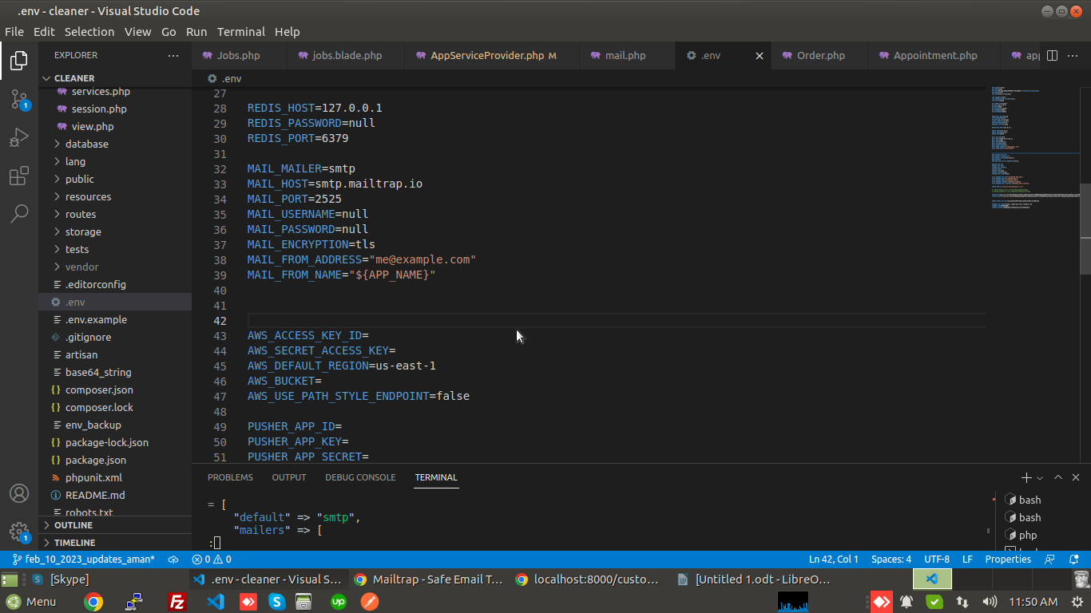

Facing Issues: -

1. only auth emails going.
2. task mails not sent eg. Job accepted, rejected, cancelled etc

solution:- in local code use :- php artisan schedule:work

but in live code maybe its not work

